**Name: Neha Antony**

**Roll No:23**

**Batch: MCA -B**

**Date:24-05-2022**

**ADVANCED DATABASE MANAGEMENT LAB**

**Experiment No.: 10**

**Aim**

Install PHP MongoDB Driver

**Procedure**

Download correct mongodb driver for PHP, based on your PHP

version, Architecture and whether Thread Safety is enabled. You can get that information from the phpinfo page.

Do the following steps to install and configure MongoDB driver on Windows XAMPP Server.

1. Download the latest stable version of the PHP MongoDB driver from following URL https://pecl.php.net/package/mongodb.

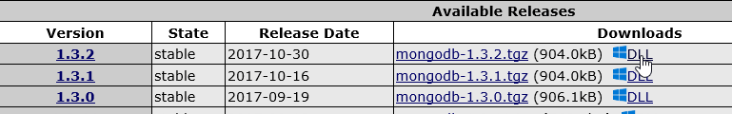

1. Extract the archive File.
2. Copy the php_mongodb.dll file from the extracted folder to the PHP extension directory. this is usually the "C:\xampp\php\ext" folder in XAMPP Server.
3. Open the php.ini file inside your PHP installation (C:\xampp\php) and add the following line:

**extension=php_mongodb.dll**

1. Save the file and close it. Restart the Apache web server.

Test MongoDB Connection From PHP Script

Let's write a very simple PHP program that creates a connection to the MongoDB server and dump the connection status.

Add following PHP code to your php script and access from the Web browser. The above PHP example will output something similar to:

**<?php**

**$connection = new MongoDB\Driver\Manager("mongodb://localhost:27017"); var_dump($connection);**

**?>**

Result

o**bject(MongoDB\Driver\Manager)#1 (2) { ["uri"]=> string(25) "mongodb://localhost:27017" ["cluster"]=> array(1) { [0]=> array(11) { ["host"]=> string(9) "localhost" ["port"]=> int(27017) ["type"]=> int(0) ["is_primary"]=> bool(false) ["is_secondary"]=> bool(false) ["is_arbiter"]=> bool(false) ["is_hidden"]=> bool(false) ["is_passive"]=> bool(false) ["tags"]=> array(0) { } ["last_is_master"]=> array(0) { } ["round_trip_time"]=> int(-1) } } }**